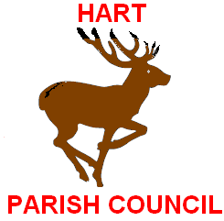

Minutes of the Parish Council Annual Meeting held in
Hart Village Hall on Monday 9th May 2016
Present Vice Chairman Parish Cllr. Keith Brown; Parish Councillors Frank Lancaster; Keith Park.
Clerk Ron Gray

The Meeting of the Parish Council opened at 1900 hrs.

- Apologies for absence John Littlefair; Jeff Moriarty; Joanne Quarmby; Hart Ward Councillors Beck, Riddle.

- The election of The Chairman for the ensuing year.
There was only one candidate John Littlefair and he was duly re-elected.

- The election of Vice Chairman for the ensuing year.
There was only one candidate Keith Brown, and he was duly re-elected.

The meeting closed at 1910 hrs.

Signed……………………… Dated………………….

Minutes of the Parish Council Annual Meeting held in
Hart Village Hall on Monday 9th May 2016
Present Vice Chairman Parish Cllr. Keith Brown; Parish Councillors Frank Lancaster; Keith Park.
Clerk Ron Gray

The Meeting of the Parish Council opened at 1900 hrs.

- Apologies for absence John Littlefair; Jeff Moriarty; Joanne Quarmby; Hart Ward Councillors Beck, Riddle.

- The election of The Chairman for the ensuing year.
There was only one candidate John Littlefair and he was duly re-elected.

- The election of Vice Chairman for the ensuing year.
There was only one candidate Keith Brown, and he was duly re-elected.

The meeting closed at 1910 hrs.

.

Signed……………………… Dated………………….

